Tanzania | Tobacco Corporation Joint Enterprise

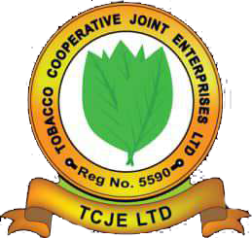

Built by growers, for growers, TCJE represents 100% farmer-owned interests in Tanzania’s tobacco sector.
By strengthening collective bargaining, improving access to inputs, and working closely with policymakers, TCJE empowers farmers to compete and thrive.
Through ITGA, TCJE ensures Tanzania’s growers have a strong voice on the global stage.

