Zambia | TAZ
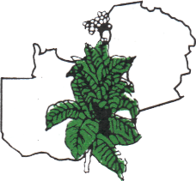

A fully farmer-led and funded organization, TAZ represents tobacco growers across Zambia – driving market access, value addition, and global competitiveness.
From operating sales floors to promoting traceability and global standards, TAZ plays a critical role in positioning Zambia tobacco internationally.
TAZ is a cornerstone of Zambia’s tobacco sector – supporting growers at every step.

